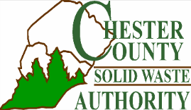
LANCHESTER RECLAMATION CENTER
(no fee)

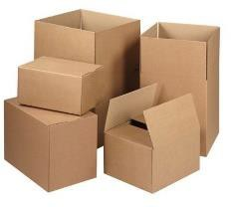
CORRUGATED CARDBOARD
Please flatten. No waxy cardboard.

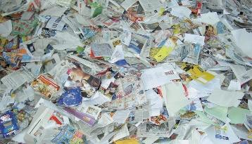
MIXED PAPER
Junk mail, cereal boxes,
soft cover books, magazines,
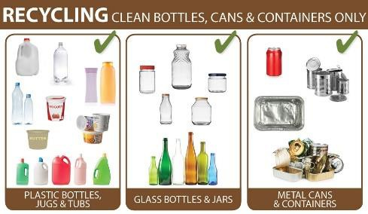
newspapers

COMINGLED FOOD AND BEVERAGE CONTAINERS Glass bottles, metal cans, plastic bottles & food containers #1-7, paper milk/soup cartons

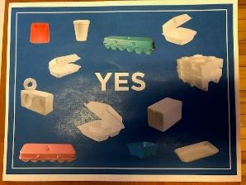
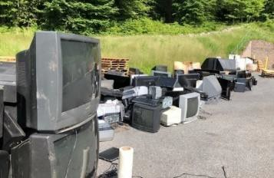
STYROFOAM™ Clean & dry, from food or
packaging

TVs, COMPUTERS & SMALL ELECTRONICS

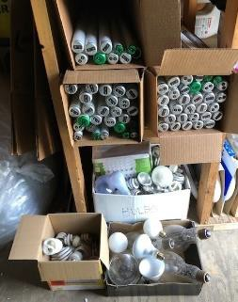

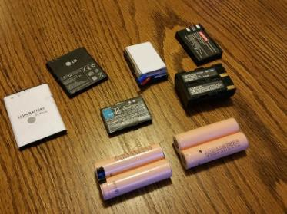
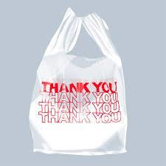
FLUORESCENT PLASTIC BAGS
TUBES

Max of 5; Unbroken No receipts.
Empty, clean and dry
RECHARGEABLE BATTERIES
(NO LEAD ACID)
Not damaged or leaking

