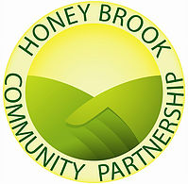

BE A HONEY BROOK HERO!
Help us bring fun and fellowship to the community during Harmony Day!

The Honeybrook Community Partnership is organizing a Family Fun Fest on Harmony Day, Saturday, September 17, 2022. Held on the fire company fair grounds and Long Way Home parking lot from 8:00 AM – 2:00 PM, the event is known to attract hundreds of members of the community.
We invite you to help sponsor this event.

Crafters, health and safety vendors, community groups, yard sales, food, and a full array of children’s games and activities offer a day of family fun to bring the community together.

We need your help to not only make this a wonderful event, but to also help the Partnership grow its ability to provide grants in support of groups doing valuable work for community residents, provide scholarships, and to continue to work on projects that make our community the best it can be.

Show the community that you care: Select one of the attached Sponsor packages.

Please feel free to contact any of the Partnership members listed below for questions regarding the sponsorships. Thank you very much for your support.

Julie Funk - juliegfunk@comcast.net
Greg Knies - greg@kniesinsurance.com
Dawn Schaffer - dawn52@ptd.net

The Mission of the Honey Brook Community Partnership is to bring together borough and township partners to facilitate communication, share resources, and work together to enhance our community. It is comprised of residents, business owners, and township and borough representatives who care. For more information visit www.hbpartnership.org.

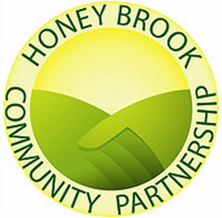
2022 Sponsorship packages:

□ Platinum Sponsor ($1,000 or More)
- Ability to set up a display at the event and/or your signage in area of high visibility
- Company logo and link on Honey Brook Partnership website and Facebook page
- Prominent inclusion in all Harmony Day promotions and public relations
- Honey Brook Community Partnership Membership

□ Gold Sponsor ($750)
- Ability to set up a display and/or your signage at the event
- Company logo and link on Honey Brook Partnership website and Facebook page
- Inclusion in all Harmony Day promotions and public relations
- Honey Brook Community Partnership Membership

□ Silver Sponsor ($500)
- Company logo and link on Honey Brook Partnership website and Facebook page
- Inclusion in all Harmony Day promotions and public relations
- Honey Brook Community Partnership Membership

□ Bronze Sponsor ($200)
- Company logo and link on Honey Brook Partnership website and Facebook page
- Honey Brook Community Partnership Membership

** To ensure your name and logo on promotional materials, please return commitment (no payment is required to ensure this) by June 15, 2022. Logos should be sent to Reuben Schonebaum at artee@ptd.net.

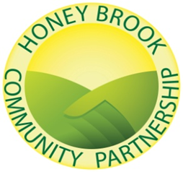

Please return entire form with your Sponsorship selection and payment to address listed below.

- Sponsorship Choice _____________________________ $___________________

Payment Due Date: August 19, 2022

*If you are unable to meet the June 15 deadline but wish to participate, please contact Tom Tracy at hbcptjt@gmail.com for payment arrangements.

Your information: (Please Print)

______________________________________________________________________________ Company Name (Please Print) Phone Number

______________________________________________________________________________Company Contact Name

______________________________________________________________________________ Street Address City State Zip Code

Email Address & Website

Please make checks payable to Honey Brook Area Community Partnership and mail to:

Thomas J. Tracy, Jr.,Treasurer
Honey Brook Community Partnership
P.O. Box 190
Honey Brook, PA 19344

