HEROS OF HONEY BROOK BOROUGH
MILITARY BANNER PROGRAM

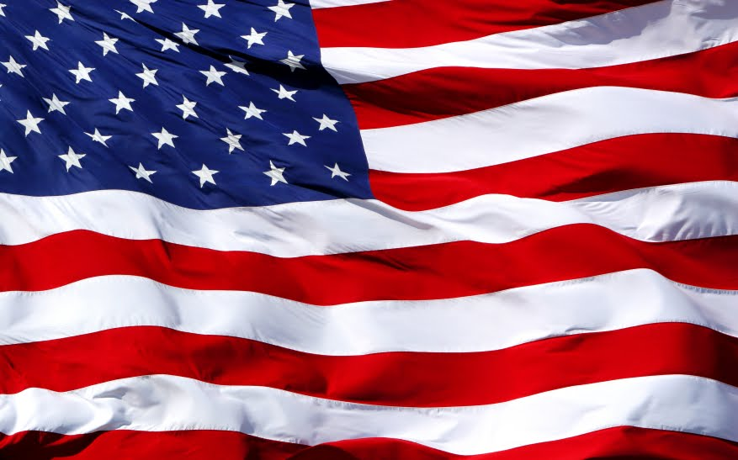

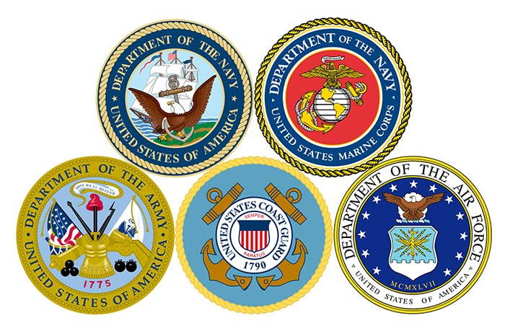

This program is intended to honor those who have served our country in the armed forces and are connected to Honey Brook Borough as a current or past resident of the Borough. Veterans of World War I, World War II, Korea, Vietnam, Persian Gulf War, Operation Iraqi Freedom and Operation Enduring Freedom (War in Afghanistan) can be honored with a sponsored banner proudly displayed in our Borough along Route 322 (Horseshoe Pike). Each banner is unique and will include a picture of the service member, their branch and period of service, and mention any awards and include the sponsor’s name.

Program Facts:

- The banners are 24 x 48 inches and will be located along Route 322 (Horseshoe Pike) within the Borough limits.

- Banners will be displayed for a 2-year period from May through November, after which the banner will be given to the family or sponsor.

- The cost of sponsorship is $200.00 for each 24” x 48” double sided banner. The sponsor or sponsoring agency’s name will appear on the bottom of the banner.

- The Honoree’s picture and information will be displayed on both sides of the banner.

- Applications are available at Honey Brook Borough Hall or online at www.honeybrookborough.net. (Borough Hall hours are M-W-F 8am to 1pm).

- Photos and applications may be electronically submitted to info@hbboro.net (please forward scanned photographs at 600dpi if possible), mailed or brought into the Borough office.

- Applications will only be processed with a fully completed form, photo and payment. A copy of the Veteran’s DD-214 as proof of service must also be attached.

- Applications mailed to the Borough will have the accompanying photo returned to the sending address.

- Payment can be made by check or money order (payable to Honey Brook Borough) at the Borough Office (address below).
Honey Brook Borough Military Banner Program
71 Pequea Avenue
PO Box 249
Honey Brook, PA 19344

Businesses and civic organizations may also sponsor a banner for a particular veteran by completing the sponsorship section of the form, the business or civic organization’s name will appear as the sponsor.
Contributions toward the program will also be accepted. If available, sponsors with no veteran designated, can be matched with a veteran whose family may not have the means to participate on their own.

SPECIAL NOTES:

Any awards or such as Purple Heart, Silver Star, or Bronze Star will be included on the banner. To confirm an award or service details the Veteran’s DD214 form can be accessed at https://www.archives.gov/veterans/military-service-records. PROOF OF SERVICE AND/OR AWARDS MUST BE SUBMITTED WITH APPLICATION.

Placement of banners will be at the sole discretion of the Borough.

Those Killed in Action, Missing in Action, POW, and Congressional Medal of Honor recipients will be honored free of charge.

Please contact Tricia Swinty at the Borough Office with any questions about the program at 610-273-2020.

